Strategic Framework for Compliant Claims Automation: Integrating AI, Deterministic Logic, and Zero-Knowledge Proofs (ZKP)

TLDR;

What it is: Zero-Knowledge Proofs (ZKP) are cryptographic techniques that allow a party to prove a statement is true (e.g., claim eligibility) without revealing the sensitive underlying data used to prove it.
How it is created: Private inputs such as medical records are processed through deterministic mathematical constraints to generate a non-readable cryptographic proof, rather than exposing raw data.
How it is used in AI systems - for example automatic claim processing:
- Only ZKP-validated, sanitized facts are shared with LLMs for policy interpretation and reasoning.
- Any legally binding AI output (approval, denial, amount) is then validated using deterministic rules and, where required, a final ZKP to ensure auditability.
Immediate relevance: Although not mandated by U.S. law, ZKP is an effective best-practice for complying with HIPAA’s Minimum Necessary principle, reducing PHI exposure, and lowering breach and audit risk in AI-driven workflows.
Future leverage: ZKP enables model attestation, allowing insurers to verify that a regulator-approved AI model was used in diagnostics or decision workflows without exposing proprietary models, patient data, or internal logs.

Concepts is demonstrated from the angle of Automatic Claim processing

Introduction
To achieve operational excellence in claims processing, we must resolve the core tension in healthcare: AI needs data to learn, patients need privacy, and regulators demand interoperability. This report outlines a three-layer stack—HL7 FHIR for data structure, Deterministic Logic/ZKP for privacy-preserving verification, and LLMs for policy reasoning. By separating legal truth (deterministic) from operational judgment (probabilistic), we can automate claims while remaining fully compliant with HIPAA, CMS, and ONC mandates.
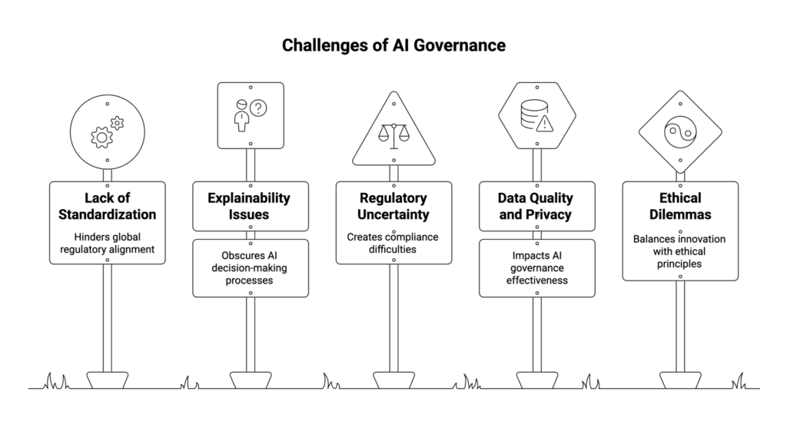

Why AI in Medical Insurance Is Different
In most industries, AI makes probabilistic recommendations. In medical insurance, a claim decision is a legally binding financial commitment.
• Probabilistic Risk: LLMs are non-deterministic and can "hallucinate." They cannot be the sole authority for denials or payments because their reasoning is statistical, not rule-bound.
• Legal Accountability: Every decision must be reproducible. A "black box" cannot hold the authority for a legal act like a benefit denial.
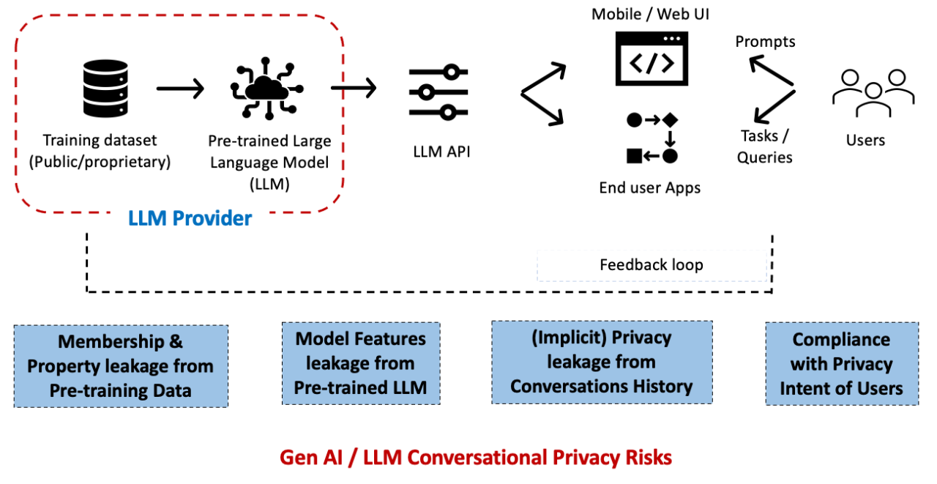

Correct Role of LLMs: The Policy Interpreter
LLMs should be viewed as "Policy Interpreters," not judges.
• What LLMs Can Do: They excel at handling "gray zones" in natural language policy. For example, an LLM can interpret whether a condition was "aggravated by non-disclosure" or if a specific treatment is "related to" a covered chronic condition.
• What LLMs Cannot Do: They must not independently approve or deny claims. They provide a recommendation that must then pass through a deterministic "gatekeeper" to become a binding decision.

Role of Deterministic Logic & ZKP
• Deterministic Logic: This handles strict business rules where no ambiguity is allowed (e.g., "Is the patient over 18?" or "Is the claim within the ₹50,000 limit?"). It scales certainty.
• Zero-Knowledge Proofs (ZKP): ZKP converts sensitive medical facts into provable truths without revealing the underlying data.
◦ Example: A provider proves a patient has a "Chronic Condition" (Statement) using a "Diagnosis Code" (Secret Data) without the insurer ever seeing the specific diagnosis.

PHI
↓
Structured extraction (deterministic)
↓
ZKP (prove facts)
↓
Sanitized facts (JSON)
↓
LLM reasoning over policy text (recommendation)
↓
Deterministic validation (constraints)
↓
ZKP (prove final decision)

Compliant Claims Automation Architecture
To ensure compliance, Protected Health Information (PHI) must never be sent to external AI APIs (e.g., OpenAI, Gemini). Instead, follow this flow:
Step | Action | Example Data
1. FHIR Data | Structured PHI stays behind our firewall. | Diagnosis: Type 2 Diabetes; Age: 35
2. Deterministic Check | Local code verifies eligibility facts. | age >= 18 is TRUE
3. ZKP Generation | Cryptographic proof is created to verify facts without revealing PHI. | zk_proof: 0x9fae12... (Binary blob)
4. Sanitized Facts | The proof is collapsed into a minimal-disclosure JSON summary for the AI. | {"eligible_for_benefit": true, "waiting_period_met": true}
5. AI Reasoning | An external LLM reasons over the Sanitized Facts + Policy Text. | "The member meets chronic criteria; I recommend approval."
6. Validation | Deterministic logic confirms the AI stayed within limits. | assert amount <= 50000
7. Final Decision | A final ZKP or immutable log records the decision for auditability. | {"decision": "APPROVE", "proof": "verified"}

Disallowed (with external APIs)
{
"diagnosis": "Type 2 Diabetes",
"lab_results": {...},
"doctor_notes": "...",
"member_id": "12345"
}

Allowed (ZKP-derived / minimal disclosure)
{
"eligible_for_benefit_X": true,
"coverage_clause_satisfied": true,
"waiting_period_completed": true,
"proof_verified": true
}

Layer | Responsibility
ZKP | Truth of eligibility
Rules engine | Deterministic math
AI | Policy Interpretation, Judgment, prioritization, optimization

To understand how Protected Health Information (PHI) is converted into Zero-Knowledge Proofs (ZKP), it is essential to view the process as a transition from sensitive data to mathematical certainty. This conversion ensures that our claims automation system can verify eligibility without ever exposing raw medical records to external AI models or unauthorized parties.

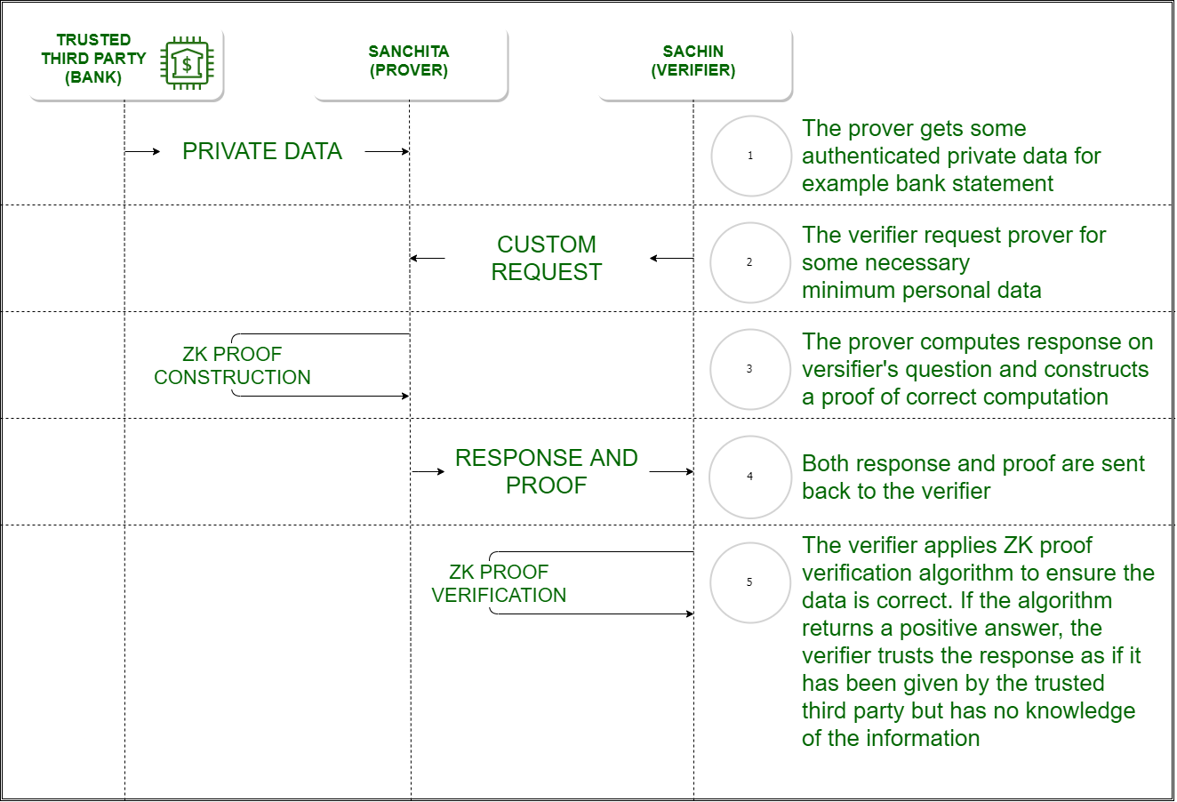

The Conversion Pipeline: From PHI to Proof

The transformation follows a strict multi-step pipeline where raw data is gradually abstracted into cryptographic evidence.
Step 1: Structured PHI (Input)
The process begins with raw clinical data, typically formatted according to the HL7 FHIR standard. This data remains strictly within our secure local boundary and never touches an external API.
• Example Data: A patient record containing age: 35, diagnosis: "Type 2 Diabetes", and enrollment_date: "2022-01-01".

Step 2: Defining the "Statement" and Constraints
Instead of sending the data itself, we define a ZKP Statement—a set of rules that must be true for a claim to be valid.
• Example Statement: "I know a patient record where the age is ≥ 18, the diagnosis is on the 'Chronic List,' and the member has been enrolled for at least 2 years".
• Conversion to Math: These rules are encoded as mathematical operations (arithmetic circuits), such as age = 18 + k (where k must be a positive number).

Step 3: Proof Generation
A ZKP "prover" application takes the private PHI and the mathematical constraints to generate a cryptographic proof.
• The Output: This is a non-readable binary blob (e.g., 0x9fae12ab...).
• The Result: This blob reveals nothing about the actual age, the specific diagnosis, or the dates. It only proves that a "witness" (the real data) exists that satisfies all the rules simultaneously.

Take private inputs
age = 35
diagnosis = "Type 2 Diabetes"
enrollment_date = 2022-01-01

Instead of:
age ≥ 18

You prove:
age = 18 + k
where k ≥ 0

Instead of:
diagnosis ∈ ChronicSet

You prove:
hash(diagnosis) ∈ {hash(D1), hash(D2), hash(D3)}

Instead of:
waiting_period ≥ 2 years

You prove:
current_date - enrollment_date = 730 + t
where t ≥ 0

All of these become math constraints, not strings.

What the Final Output Means
Once the proof is generated, it is verified. If successful, the system produces a Sanitized JSON output for the AI reasoning layer. It is critical to distinguish between the proof (the mathematical evidence) and the JSON (the business result).

The Business Meaning (The JSON)
The final output seen by our AI policy agents is a derived summary of facts.
• Example Output:
• What this tells the AI: It confirms that "paying is allowed" according to legal policy, but it does not reveal "why" in a clinical sense (e.g., it doesn't mention the diabetes).

The Legal Meaning (The Auditability)
For our legal and compliance teams, the final output represents non-repudiation. Because the proof is cryptographically "bound" to a specific claim ID and policy version, the output means:
1. Truth: The claim is mathematically guaranteed to meet the rules.
2. Immutability: The decision cannot be disputed or altered later because any change to the underlying data would make the proof fail verification.
3. Minimum Necessary: We have satisfied the HIPAA "Minimum Necessary" rule by proving eligibility without disclosing the actual medical chart.

Summary Table
Stage | Format | Meaning to the System
Input | FHIR PHI | The private, sensitive medical facts.
Process | Cryptographic Circuit | The "black box" that checks the rules.
Proof | Binary Blob | The mathematical "trust" that rules were followed.
Final Output | Sanitized JSON | The "Provable Truth" that AI uses to execute the claim.
In short, the conversion turns sensitive data into provable facts, allowing the AI to focus on "operational excellence" (how much to pay) while the ZKP handles "legal correctness" (can we pay)
The auditability of a Zero-Knowledge Proof (ZKP) does not come from the binary blob itself, but from the fact that the blob is mathematically bound to specific, non-secret metadata called Public Inputs.

While the "witness" (your sensitive PHI) remains hidden, the proof is cryptographically locked to the "keys" or context you suspected. Here is how that "meaningless" blob becomes an auditable record:
1. The Role of Public Inputs (The "Keys")
A ZKP system separates data into Private Inputs (which stay hidden) and Public Inputs (which are revealed and audited). To make a proof auditable, we include context-specific "keys" as public inputs so the proof cannot be used for any other purpose.
• Claim Context Binding: We include a hash of the claim_id and member_id as public inputs. This ensures the proof is only valid for that specific claim and cannot be "replayed" for a different person.
• Policy Version Binding: The proof is bound to a specific version of our insurance policy (e.g., "Policy_v2024.3"). If the rules change next year, an old proof will fail verification against the new policy hash.

2. Constraint Binding (The Rules)
Auditors do not need to see the patient's diagnosis to verify the claim was handled correctly; they need to see that the correct rules were followed.
• In a ZKP system, the entire set of rules (e.g., "Age > 18" and "Diagnosis is Chronic") is compressed into a Constraint Hash.
• The binary blob only verifies as "TRUE" if it was generated using the exact mathematical constraints represented by that hash.
• If a prover tried to use different, unauthorized rules, the mathematical verification would fail immediately.

3. What the Auditor Actually Checks
In an audit, the official doesn't look inside the "blob." Instead, they look at the Verification Log, which contains the following immutable links:
• Statement: "Was the proof verified successfully?" (TRUE/FALSE).
• Constraint Hash: "Which rules were satisfied?".
• Context: "Which member and claim does this apply to?" (via hashes).
• Timestamp: "When did this happen?".

Summary of Auditability
The Auditor Asks: | The ZKP System Provides: | Does it reveal PHI?
Is the decision true? | Mathematical proof of rule-following. | ❌ No.
Which rules were used? | The public Constraint Hash. | ❌ No.
Whose claim is this? | The public Claim ID Hash. | ❌ No.
Can this be disputed? | The Immutable Log (often on blockchain). | ❌ No.
In short, ZKP is auditable because it is not reversible. It proves that a specific process was followed for a specific claim without ever revealing the private data that triggered the process. This allows us to satisfy the HIPAA "Minimum Necessary" rule while providing a tamper-evident record for regulators.

Multi-Agent Systems & Auditability
In agentic workflows, we do not need to audit the intermediate "thoughts" of every sub-agent (e.g., a "Policy Search Agent").
• The Decision Point: Auditability and ZKP generation are only required at the Decision Authority level—the point where the system state changes (e.g., triggering a payment).
• Binding Context: The ZKP must bind the exact policy version and claim ID to the decision so that it cannot be disputed or reused for another patient later.

Automation vs. Human Oversight
Full automation is compliant under U.S. law if the authority is deterministic.
• When to Automate: High-volume, routine claims where the logic is clear. A system can auto-send an approval email without a human if the deterministic validator confirms the LLM's recommendation followed the rules.
• When to Use Humans: High-risk exceptions, complex appeals, or cases where the LLM's confidence score is low.

U.S. Regulatory Reality
There is no "approved list" of AI models. Regulators (HHS, CMS, ONC) focus on outcomes:
• HIPAA: Must follow the "Minimum Necessary" rule. ZKPs achieve this by proving facts without revealing data.
• ONC/CMS Rules: Mandate the use of HL7 FHIR APIs for data exchange.
• Auditability: You must provide a verifiable trail showing that decisions followed the policy in force at that time.

Future Outlook: AI Diagnostics & Model Attestation
In the near future, insurers may require cryptographic attestations to verify that an AI-assisted diagnosis was produced by an FDA-cleared model.
• Example: A diagnostic device produces a ZKP proving "This diagnosis was generated by Model v3.1 (FDA-cleared)" without revealing the proprietary model weights or the raw clinical data.

Compute a hash:
model_hash = H(canonical_model)

Require:
deployed_model_hash == reference_model_hash

Key Risks If Done Incorrectly
• Data Breach Liability: Sending raw PHI to external AI APIs without a Business Associate Agreement (BAA) and strict minimization is a HIPAA violation.
• Regulatory Fragility: If the "Decision Authority" is probabilistic (LLM-only), the organization cannot mathematically defend its decisions during a CMS audit.
• Fraud: Without binding the ZKP to a specific claim context, proofs can be "replayed" to fraudulently approve different claims.

The Mechanism of Replay Fraud
A ZKP typically proves a statement like, "This patient is over 18 and has a covered chronic condition". If the proof is designed as a "generic proof," it only confirms that the statement is true for someone.
If we do not bind that proof to a specific context:
• The Risk: A bad actor could intercept a valid "Eligibility Proof" generated for a legitimate $5,000 claim and "replay" (re-submit) that same proof to trigger an approval for a completely different, potentially fraudulent claim.
• The Outcome: Our automated system would see a mathematically "valid" proof and approve the payment, unaware that the proof was actually generated for a different patient or a different medical event.

The Technical Solution: Contextual Binding
To prevent this, our architecture must use Public Inputs to anchor the proof to a specific "witness" or context. We do this by including the following identifiers directly in the cryptographic statement:
• Claim Context Binding: We include a cryptographic hash of the claim_id and the member_id as part of the proof's public inputs. This ensures the proof is only valid for that specific claim and that specific member.
• Policy Version Binding: We bind the proof to the exact policy version (e.g., "Policy_v2024.3"). This prevents a fraudster from using an old proof that was valid under a previous, perhaps more lenient, set of coverage rules.
• Constraint Hashing: The specific rules used to generate the proof (e.g., "Age > 18") are themselves hashed into a "constraint hash". If a prover tries to use a different set of rules, the verification will fail.

Why This Matters for Auditability
For our compliance and legal teams, this binding provides Non-Repudiation. Because the proof is bound to a specific context, an auditor can verify years later exactly which rules were satisfied, for which member, and at what precise time.
By utilizing Immutable Audit Logs (such as a blockchain or a secure append-only ledger) to record these bindings, we ensure that once a proof is accepted, it can never be altered or disputed

Relevance of Block Chain in this context

In the context of medical insurance and claims automation, blockchain is not utilized for the actual ZKP computation; instead, it serves the critical functions of trust, ordering, and auditability. While a ZKP provides a mathematical proof that a statement (such as claim eligibility) is true, it cannot independently verify who performed the verification, when it occurred, or if the record was subsequently altered.

In a compliant claims architecture, blockchain fits into the system in the following specific ways:

• Immutable Audit Log: When a ZKP is verified, the blockchain records only the metadata—such as the claim ID hash, the proof status, and the timestamp—creating a permanent record that auditors can use to verify that no decisions were changed after the fact.

• Non-Repudiation: It ensures that once a claim is approved, the decision is cryptographically undeniable. This prevents a payer from later denying an approval and protects the provider from disputes regarding timelines.

• Cross-Organization Trust: The healthcare ecosystem involves payers, providers, and regulators who do not inherently trust one another. Blockchain replaces the need for shared spreadsheets or central "trust brokers" by providing a single, verifiable event history accessible to all authorized parties.

• Trust Anchoring: A typical architecture keeps sensitive work off-chain—including FHIR data, ZKP generation, and AI reasoning—while only the "trust anchors" (hashes and verifier identities) are stored on-chain to maintain system performance and privacy.

A helpful mental model for this relationship is that ZKP answers "Is this true?" while blockchain answers "Can this ever be disputed?". While blockchain may not be necessary for single-organization internal systems, it becomes a critical component in zero-trust environments where regulatory audits or legal disputes between multiple organizations are likely.

Historically, these technologies became linked because blockchain platforms like Ethereum provided the first practical, trustless environments where ZKP state transitions were required to prove correctness without revealing private data

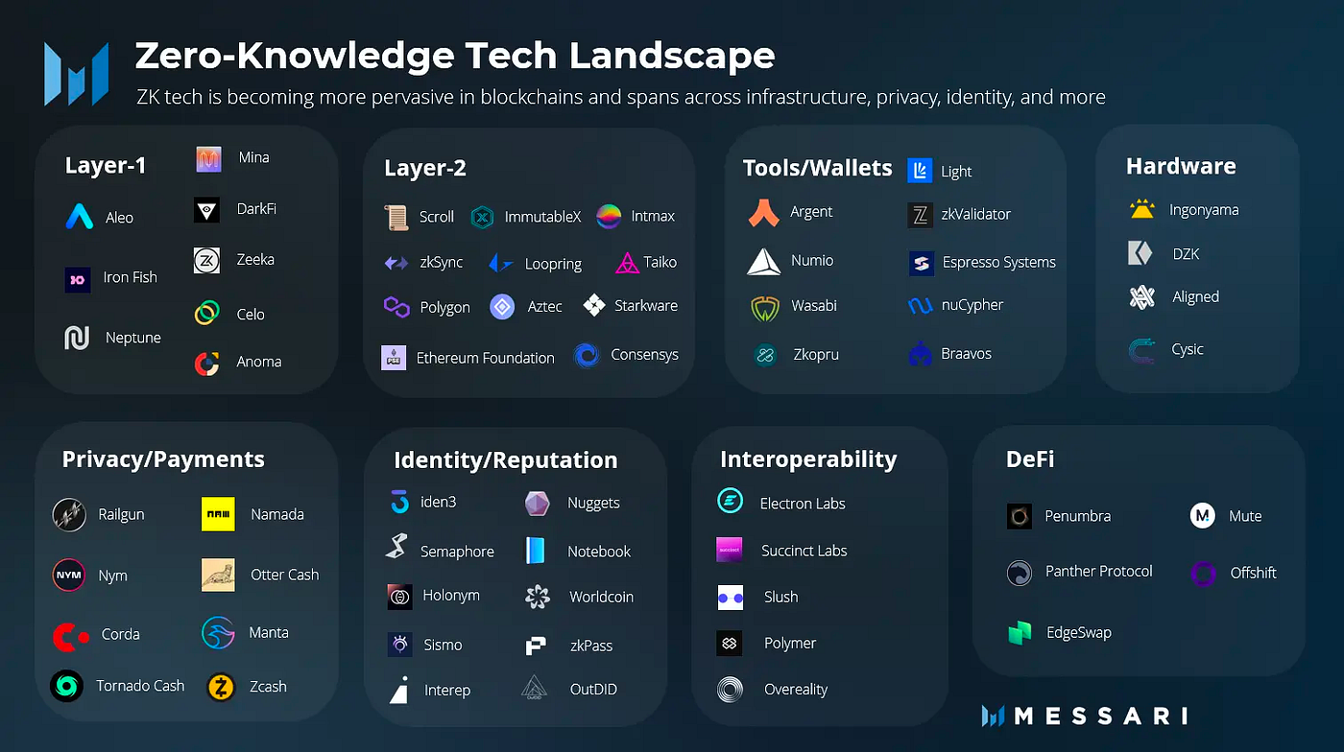

Final Recommendations
1. Deploy a Hybrid Stack: Use FHIR for interoperability, Deterministic Logic for authority, and LLMs for reasoning.
2. Enforce the "Sanitized Interface": Ensure LLMs only see ZKP-verified "Sanitized Facts" (JSON), never raw medical records.
3. Audit the Decision, Not the Agent: Focus cryptographic proofing on the final binding decision point.
4. Adopt Immutable Logging: Use append-only logs (or blockchain metadata) to anchor ZKP proofs, ensuring decisions cannot be altered post-hoc

Some example References:
https://www.mdpi.com/2306-5354/12/11/1236

https://www.researchgate.net/publication/399473287_Agentic_AI_in_Healthcare_Medicine_A_Seven-Dimensional_Taxonomy_for_Empirical_Evaluation_of_LLM-based_Agents

https://github.com/csalvador58/verifiable-credential-zk-health-record/tree/main

https://www.hl7.org/fhir/datatypes.html

https://tde.fi/founder-resource/blogs/technology/cryptographic-techniques-beyond-zkps-to-enhance-privacy-in-web3-applications/#:~:text=3%20Cryptographic%20Methods%20Beyond%20ZKPs,11%20Closing%20Thoughts

https://www.blog.encode.club/digital-identity-hackathon-sponsored-by-onyx-by-j-p-morgan-prizewinners-and-summary-5edbfc178f0d

https://github.com/anj20/MediChain

https://www.mid-day.com/buzz/article/what-is-zero-knowledge-proof-and-how-it-builds-a-simple-safe-system-for-private-ai-8199

https://www.geeksforgeeks.org/computer-networks/zero-knowledge-proof/

